Document title with badge icon behindContact info text box

**Index:**

1. Abstract
2. Introduction
3. Methodology
4. Controlling Home using Google Home
5. Home Surveillance - Security
6. Entertainment
7. Fire Emergency Response System - Safety
8. Conclusion
9. Reference
10. **ABSTRACT**

In today’s world, we preferred automatic systems over manual system and this advancement of Automation makes our lives easier and simpler. Number of Internet users increasing over past decade has made internet a part of their lives and IoT is latest and trending technology. Internet of Things is the idea of remotely connected and monitored real world objects which considered as ‘Things’ in IoT, using internet. This paper discusses about IoT and how it can be used for building smart home automation using various technology and devices. The approach focuses on how data flows between different devices and how it relates to Internet of Thing concept.

**2) INTRODUCTION**

**What is IoT?**

The concept of Internet of things(IoT) was presented by the development of the broadly utilized worldwide system known as the web along with physical objects or things, those are integrated into the information network and these objects become active participants in whole process which opens new doors for the creation of innovative answers to various aspects of life. The idea of Internet of things makes a network of objects that can convey, communicate and participate together to achieve a common objective. A “thing” in the Iot, has unique identity and can be anything such as a person with a heart monitoring implant, any vehicle that works under sensors to caution the driver when tier pressure is low, a camera streaming live activities or it can be defined as mixture of hardware, software, data, service, communication protocol and so much more[1]. IoT gadgets can improve our lives, as each of it stops acting as single device and turn out to be part of a fully connected framework. This gives us the subsequent information to be analysed for better decision making, and tracking business and monitoring our properties while we are away from them.

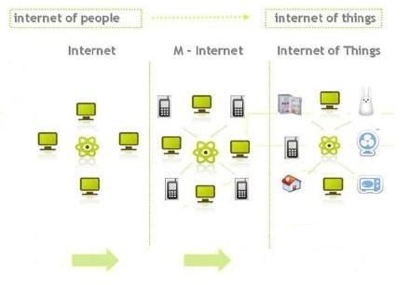

**Fig: Shows the Evolution of Internet and Internet of Things**

**What is Home Automation?**

Home Automation gives you control to access gadgets in your home from any device, from anyplace in the world. Home Automation describes as homes in which about everything – lights, heating and cooling system, appliances, -- are hooked up to a remotely controllable network. From security perspective, this additionally incorporates safety alarm system, all doors, locks, windows, surveillance cameras, smoke detectors etc. It is a step toward “internet of things”, in which each device has an IP address and can be monitored and retrieved remotely[2].

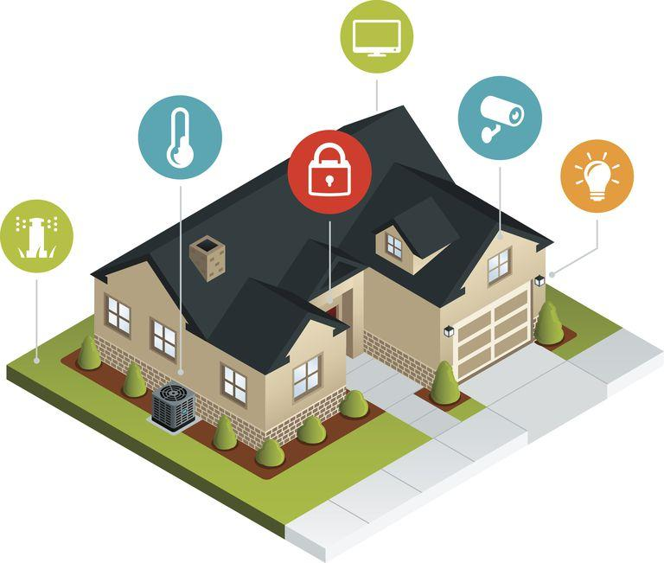

**Fig: Home Automation Components**

**3) METHODOLOGY**

**a) Controlling Home with using Google Home:**

**Supported Home Devices**

1. Nest Thermostats
2. Philips Hue Lighting
3. Samsung SmartThings
4. Honeywell
5. Belkin WeMo
6. If This, Then That (IFTTT)
7. Other Streaming Devices & TVs

**1) Set Up Smart Home Devices**

To set up you can follow the following video.

<https://www.youtube.com/watch?v=OcBXt8CQgBo>

**2) Connect Devices to Your Google Home**

1. Make sure your mobile device or tablet is connected to the same Wifi as your Google Home device.
2. Open the Google Home app.
3. In the top left corner of the Home screen, tap Menu.
4. Verify that the Google Account that is listed is the one linked to Google Home. To switch accounts, click the triangle to the right of the account name.
5. Tap Home Control.
6. In the "Devices" tab, at the bottom right tap Add.
7. Tap the type of device you want to connect, then follow the steps.
8. When pairing is complete, tap Done.

Note: There isn't a limit to the number of devices you can connect to Google Home.

**3) Set Names (Nicknames) for Devices**

You can choose names to call your smart home devices.

1. Open the Google Home app.
2. In the top left corner of the Home screen, tap Menu à Home.
3. In the "Devices" tab, tap a device you want to rename.
4. Tap Nickname à Enter Nickname à OK.
5. To see your device’s new nickname, tap Device Details.

Note: Nicknames are alternate ways to reference lights in the Google Home app. Nicknames you've assigned to lights in the Google Home app are not reflected in the partner app.

**4) Assign Devices to Room**

1. To assign Device to Room, you may follow the steps as mentioned below:
2. Open the Google Home app.
3. In the top left corner of the Home screen, tap Menu à Home Control.
4. In the "Rooms" tab, at the bottom right tap, Add.
5. From here you can either:
6. Select a room.
7. Add a new room: Scroll down, then tapCustom Room à Enter a New Room à OK.
8. To add a device to that room, tap the box next to the device name à Done. You can add each device to only one room.

**5) Control Devices using Voice Commands**

To Control Lights:

|  |  |
| --- | --- |
| To do this: | Say "Ok Google" or “Hey Google," then... |
| To turn on/off a light | "Turn on <light name>" |
| Dim a light | "Dim the <light name>" |
| Brighten a light | "Brighten the <light name>" |
| Set a light brightness to a certain percentage | "Set <light name> to 50%" |
| Dim/Brighten lights by a certain percentage | Dim/Brighten <light name> by 50%" |
| Change the color of a light | "Turn <light name> green" |
| Turn on/off all lights in room | “Turn on/off lights in <room name>" |
| Turn on/off all lights | “Turn on/off all of the lights” |

To Control Switches or Plugs:

|  |  |
| --- | --- |
| To do this: | Say "Ok Google" or “Hey Google," then... |
| Turn on/off plugs | “Turn on/off the [plug name]" |
| Turn on/off switch | “Turn on/off the [switch name]” |
|  |  |

To Control Security Cameras:

|  |  |
| --- | --- |
| To do this: | Say "Ok Google" or Hey Google," then.. |
| Start stream | · "Show [camera name]"  · "What’s on [camera name]?"  · "[Camera name] on [Chromecast device name]"  · "Play [camera name] on [Chromecast device name]"  · "Show [camera name] on [Chromecast device name]" |
| Stop stream | "Stop [TV/Chromecast device name]" |

To Control Washers:

|  |  |
| --- | --- |
| To do this: | Say "Ok Google" or "Hey Google," then.. |
| Start washer | · "Start washing my clothes"  · "Do the laundry"  · "Start the [washer name]"  · "Is the [washer name] running?" |
| Stop washer | · "Stop washing my clothes  · "Stop the [washer name]" |
| Pause washer | · "Pause the [washer]" |
| Run cycle | · "What cycle is the [washer name] in?"  · "How much time is left on the [washer name] cycle?"  · "How much time is left on the [washer name]?"  · "What cycle is the [washer name] doing next?"  · "Is the laundry clean?"  · "What is the [washer name] doing?" |
| Modes | · "Set [mode name] on [washer name] to [mode value]"  · "What's [washer name] [mode name] set to?" |
| Toggle on/off | · "Turn on [toggle name] on the [washer name]"  · "Turn off [toggle name] on the [washer name]"  · "What's <dryer name> <mode name> set to?Is [washer name] [toggle name] turned on?" |

To Control Dryers:

|  |  |
| --- | --- |
| To do this: | Say "Ok Google" or "Hey Google," then.. |
| Start dryer | · "Dry my clothes"  · "Start the [dryer name]"  · "Is the [dryer name] running" |
| Stop dryer | · "Stop drying the laundry"  · "Stop the [dryer name]" |
| Pause dryer | · "Pause the [dryer name]" |
| Run cycle | · "What cycle is the [dryer name] in?"  · "How much time is left on the [dryer name] cycle?"  · "How much time is left on the [dryer name]?"  · "What cycle is the [dryer name] on next?"  · "Are the clothes dry?"  · "What is the [dryer name] doing? |
| Modes | · "Set [mode name] on [dryer name] to [mode value]"  · "What's [dryer name] doing?"  · "What's [dryer name] [mode value] set to?" |
| Toggle on/off | · "Turn on [toggle name] on the [dryer name]"  · "Turn off [toggle name] on the [dryer name]"  · "Is [dryer name] [toggle name] turned on?" |

To Control Dishwashers:

|  |  |
| --- | --- |
| To do this: | Say "Ok Google" or "Hey Google," then.. |
| Start dishwasher | · "Wash the dishes"  · "Start the [dishwasher name]"  · "Is the [dishwasher name] running?" |
| Stop dishwasher | · "Stop washing the dishes"  · "Stop the [dishwasher name]" |
| Pause dishwasher | · "Pause the [dishwasher name]" |
| Run cycle | · "What cycle is the [dishwasher name] in?"  · "How much time is left on the [dishwasher name] cycle?"  · "How much time is left on the [dishwasher name]?"  · "What cycle is the [dishwasher name] on next?"  · "Are the dishes clean?"  · "What is the [dishwasher name] doing?" |
| Modes | · "Set [mode name] on [dishwasher name] to [mode value]"  · "What's [dishwasher name] [mode name] set to?"  · "Did I set [dishwasher name] to [mode value]?" |
| Toggle on/off | · "Turn on [toggle name] on the [dishwasher name]"  · "Turn off [toggle name] on the [dishwasher name]"  · "Is [dishwasher name] [toggle name] turned on?" |

**6) Disconnect Devices from Google Home**

To disconnect,

1. Open the Google Home app
2. In the top left corner of the Home screen, tap Menu à Home Control
3. In the "Devices" tab, at the top right tap More à Manage Accounts
4. Tap the account you want to disconnect à Unlink Account à Disconnect.

**b) Home Surveillance:**

**Raspberry Pi Home Security System:**

The home security system is becoming a major part of every household because of the increasing crime and wanting to stay alert about different activities happening around in the house. Before, these systems were costly and not everyone could afford to have one, however, with decrease in the cost of cameras and sensors, it is simpler to build one using a raspberry pi.

**Hardware Connections:**

To build a home security system using a raspberry pi 3 modules, we will need a raspberry pi camera module, a passive infrared (PIR) motion sensor module, and three female-to-female jumper wires. First, we need to connect PIR motion sensor to the raspberry pi using the female-to-female jumper wires. The PIR sensor has three pins, the GND labelled pin will connect to the GND pin of raspberry pi to complete the circuit, the VCC labelled pin will connect to the 5V pin of raspberry pi to power the PIR sensor, and the OUT pin will connect to any of the pin labelled GPIO number to output the voltage send by PIR sensor on detecting motion. After connecting the sensor, we need to connect the camera module. The camera connector is present in between the HDMI port and the Ethernet RJ45 of the raspberry pi, we need to insert the flex cable of the camera module inside the camera connector of the raspberry pi.

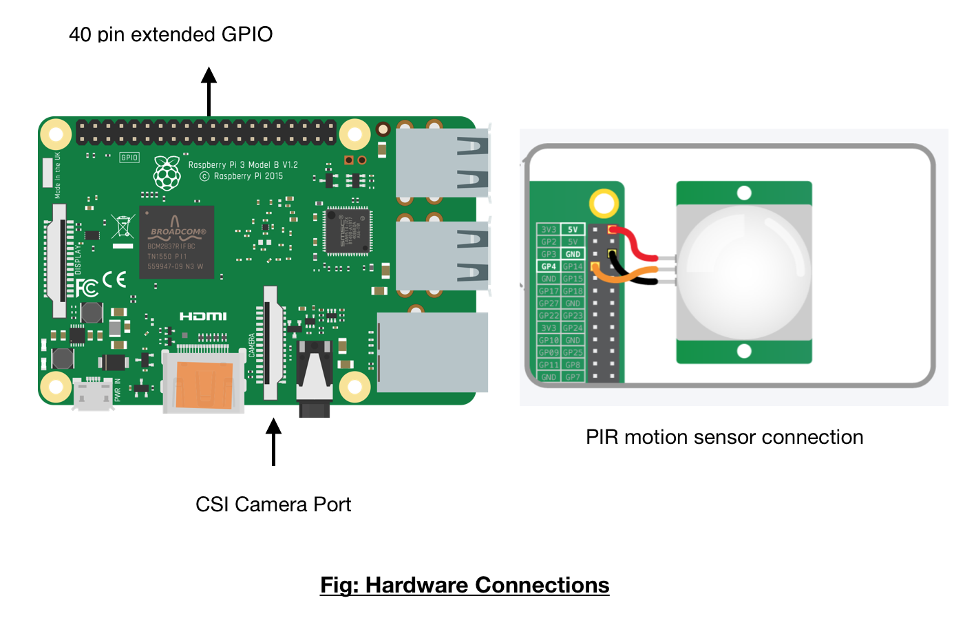

Working of the Home Security System: The PIR motion sensor gets triggered on detecting presence of a warm body around it, which sends commands to the raspberry pi camera to start video recording or click a photo of the intruder in the house. The PIR motion sensor has the capacity to detect objects emitting infrared radiations within the range of twenty feet. As soon as the sensor detects motion, a output voltage is signaled to the raspberry pi which sends command to the camera pi to click photos or start video recording. Below is the diagram showing follow of information when a motion is detected. After the video recording is complete, an alert email is send to the house owner containing the video of the intruder.

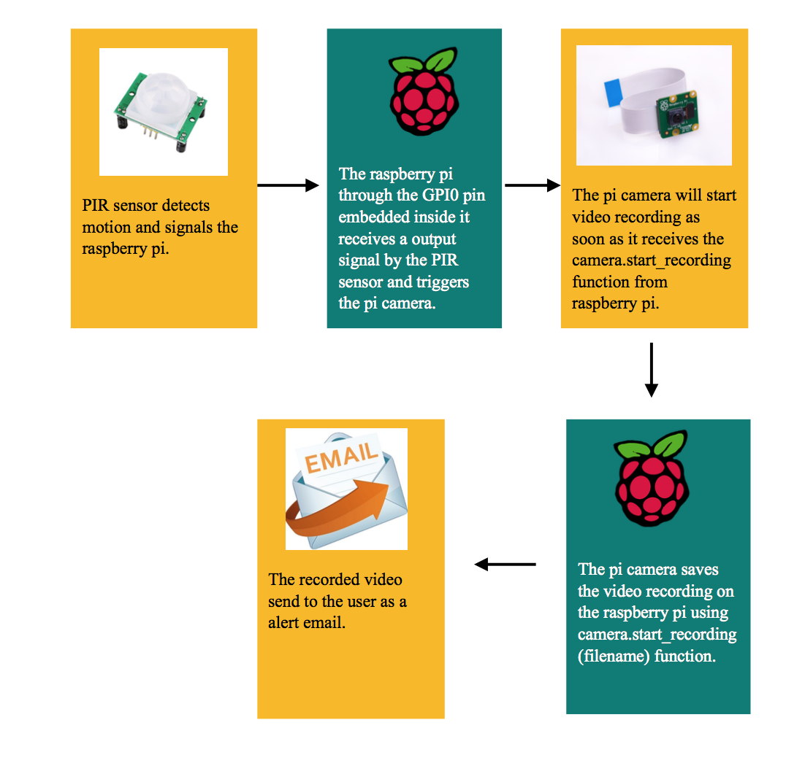

**Fig:**

**c) Entertainment:**

The growth of interconnected home automation and developments in wireless smart technology has led to an explosion in the range of smart home entertainment devices now available for building a truly connected viewing and listening experience. Smart entertainment devices primarily allow the simplification of controlling media and devices through voice, touch, making an accessible and connected environment throughout entire smart home.

**Setup for home theatre:**

The components needed for setting up home theatre are home theatre receiver, TV or video projector with screen, antenna, cable or satellite box(optional), Blu-ray/DVD/CD Disc player, media streamer, DVD recorder, loudspeakers, subwoofer, wire stripper, label printer, Sound meter. The components like satellite/Cable box, media streamer, Blu-ray disc or DVD player as beginning point and TV and loudspeakers as end-point. The home theatre receiver is centrepiece. If we want to receive TV programs via antenna, connect that antenna directly to TV. For using a cable, connect incoming cable to box. For high resolution movie media, Blu-ray Disc player is preferred, the connection setup will depend on whether Home Theatre Receiver has [HDMI connections](https://www.lifewire.com/hdmi-facts-high-definition-multimedia-interface-1847337), and whether receiver can access both the audio and video signals going through the HDMI connections. If the latter, then all we have to do is connect the HDMI output from the player to the receiver and from the receiver to your HDTV. For DVD player, connect one of the video outputs of DVD player to the DVD player video input on AV Receiver. If DVD player has an HDMI output, connect it to home theatre receiver. For connecting a CD-only player or changer to AV receiver, use either the CD player's analogue or digital audio outputs to the AV Receiver. For media streamer, such as a Roku or Amazon Fire TV stick or box, or Google Chromecast, first make sure it is connected to the internet via Ethernet or Wi-Fi. To access streaming programming from these devices on TV can be done with option of connecting it on TV directly or connecting it to the home theatre receiver - using HDMI in both cases. For video, Connect the TV monitor output (preferably HDMI) of the AV receiver to one of the video inputs (preferably HDMI) on your TV. For audio, Connect the audio outputs of your TV to the TV or Aux audio inputs on your AV receiver. To complete home theatre setup, connect the speakers to AV receiver. We need to see correct polarity and make sure speakers are connected to correct channel. Connect the subwoofer line output of AV receiver to subwoofer. Position the loudspeakers. Wi-Fi and Wireless Networking done by having a wireless transmitter/receiver built into the laptop, or other devices, communicate with a central router that may have a combination of both wireless and wired connections. The result is that any of the devices connected to the router can access the internet directly or communicate with the other devices connected to the router.

For iPod, iPhone, iPad, or Apple TV, the wireless streaming connection option AirPlay is used.

**Working structure of Home theatre:**

The audio/video (a/v) receiver and amplifier assembly in a home theatre does the same job as the receiver and amplifier assembly in any stereo system. It receives signals from various input devices, like a DVD player or satellite dish. It interprets and amplifies those signals and then sends them to output devices such as television and sound system. The receiver sends the video onto television and sends the audio to the decoder. The decoder sorts out the different sound channels from the video signal, and then sends the information to amplifiers for each sound-channel output. These amplifiers are connected to the appropriate speaker or speakers. There are different speaker setups and formats such as 5.1, 6.1, 7.1.

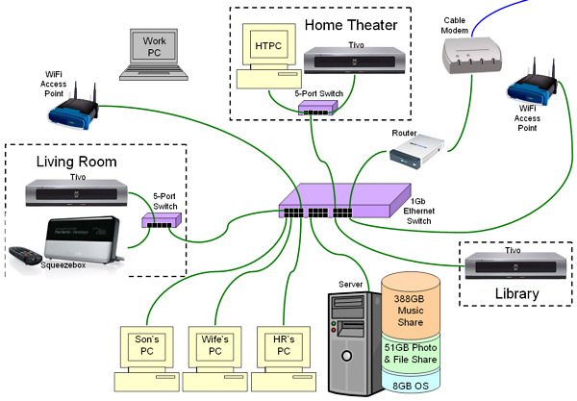

**Fig: Home Theatre Set Up**

## Smart Home Control with Alexa:

Alexa is Amazon’s voice service and the brain behind millions of devices like the Amazon Echo. Alexa provides capabilities, or skills, that enable customers to create a more personalized experience. Customers can use Alexa to control smart home devices such as cameras, door locks, entertainment systems, lighting, and thermostats. It is Amazon’s cloud-based voice service available on tens of millions of devices from Amazon and third-party device manufacturers. With Alexa, we can build natural voice experiences that offer customers a more intuitive way to interact with the technology they use every day. Alexa can be integrated with other devices in home and create more personalised experience. It includes Alexa skills kit which is a collection of APIs, tools, documentation and code samples that makes it fast and easy to add skills to Alexa. We can add voice to our ideas. Connect smart home devices to Alexa to reach and delight more customers. There are built-in voice user interface to control connected devices from tens of millions of Alexa-enabled endpoints.

**Amazon’s Alexa-controlled Echo speaker** is a wireless speaker, but capable of much more. Using nothing but the sound of our voice, we can play music, search the Web, create to-do and shopping lists, shop online, get instant weather reports, and control popular smart-home products. Echo, always listening via Amazon’s Alexa voice service, play music, order pizza, and get answers to questions, and can control popular smart-home devices and 1,000-plus other things. Just ask for a song, artist, or genre from Amazon Music, Spotify, Pandora, and more. With multi-room music, we can play music on compatible Echo devices in different rooms. Echo can also play audiobooks, radio stations, news briefs, and more.

It facilitates to Call or message anyone hands-free with Echo device. Also, instantly connect to other Echo devices in home using just voice.

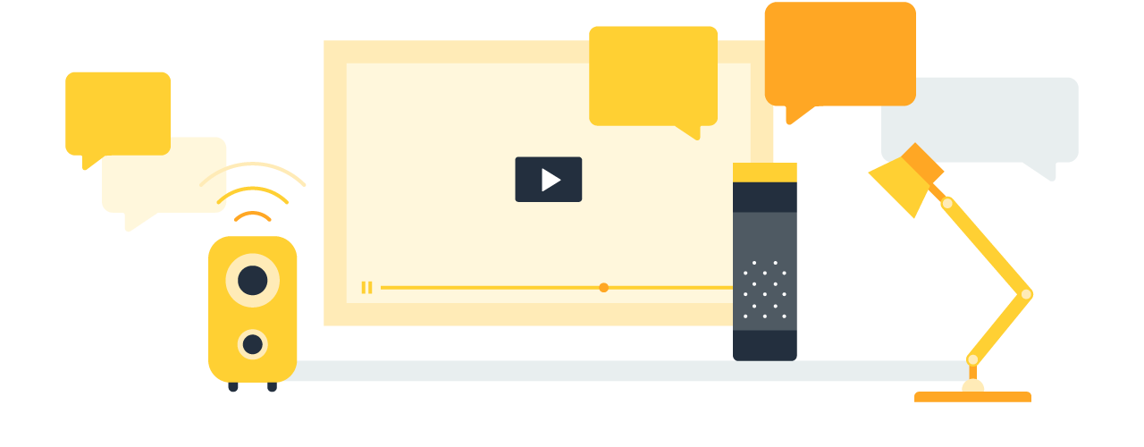

**Features:**

1. **Built-in Voice user interface**-We don’t need to design a voice user interface, or VUI, when use Alexa to control your smart devices; instead, we can use Alexa’s built-in smart home VUI.
2. **Choice of connectivity**-We can connect smart devices to Alexa using the internet and a Smart Home Skill, using Echo Plus and ZigBee, or using a smart home hub.
3. **Low barriers to adoption**-By integrating with Alexa, we can control devices from any endpoint with Alexa built-in.
4. **Rich, multi-device experiences-**We can simplify use of devices with Alexa Routines and Groups. With Routines, we can trigger a series of actions from one or more devices using a single voice command, or automatically by time of day. With Groups, we can control the devices in the same room as an Echo device without remembering specific device names.

**Device Support:**

* **Smart home Cameras**-Ask Alexa to view live video feeds from WiFi and wired smart home cameras on Echo Show and Fire TV. Using the Smart Home Skill API, we can specify a variety of camera stream attributes, including protocol, resolution, authorization type, and codecs.
* **Entertainment devices-**Voice control of smart TVs, receivers and other entertainment devices including inputs, channels, and speakers. With playback controls, you can also enable customers to fast forward, rewind, and pause.
* **Lighting**-To turn smart lights on and off, change the brightness of lights, and specify colors and color temperatures using Alexa.
* **Door Locks**-Alexa can check the state of door locks, and lock them. We can choose whether to respond to lock requests synchronously or asynchronously, depending on, among other factors, how fast device can complete the request.
* **Thermostats**-To control thermostat settings and to report current temperatures. The Smart Home Skill API supports single, dual, and triple setpoint thermostats, as well as mode query and control.
* **Other Devices**-In addition to using Alexa interfaces specifically designed to enable control of smart home cameras, entertainment devices, lights, locks, and thermostats, you can control other smart home devices using broadly applicable primitives: for example, you can use power control interface for turning nearly any smart device on or off, and the percentage control interface for setting intensity or speed.

**Connections for Alexa:**

Connect via the Internet: 

If we connect devices via the internet, we will also need to build own Alexa skill using Smart Home Skill API. This approach enables to control devices with any Alexa-enabled endpoint without requiring a hub.

Connect via a Hub:



If we connect using ZigBee(IEEE 802.15.4-based specification for a suite of high-level communication protocols used to create personal area networks with small, low-power digital radios) and Echo Plus(smart speakers) or a third-party smart home hub, then rely on Echo Plus or a skill written by the hub maker. This means we do not need to build own skill for Alexa.

### How to Deliver a Great Smart Home Experience:

1. Learn Alexa Smart Home Skill API and add voice control to smart devices.
2. Connect devices, which capabilities to expose, and whether to write your own smart home skill.
3. Use the Alexa Skills Kit and Smart Home Skills API to quickly integrate your smart home device with Alexa.
4. Launch in the Alexa Skills Store and submit products for certification via the Works with Amazon Alexa program.

**Below is the link for building skills with Alexa skills kit:**

<https://developer.amazon.com/docs/ask-overviews/build-skills-with-the-alexa-skills-kit.html>

**Advantages:**

* Add voice control to devices
* Support rich,multi-device experiences

**Below is the link for Alexa skills demo that we created:**

<https://www.youtube.com/watch?v=y9wtn-0wEHQ>

**c) Fire Emergency Response system:**

Now a day due to the complex structured building has made the emergency evacuation during the blackout caused by any natural disasters like fire, building collapse or an earthquake when vision has been impeded due to smoke. This intelligent IoT emergency evacuation system will make the detours according to the occurrence of the fire in the building to minimize the casualties. Using different sensors like flame detector, heat detector, vibration sensor, ultrasonic sensor.

**Wireless sensor network:**

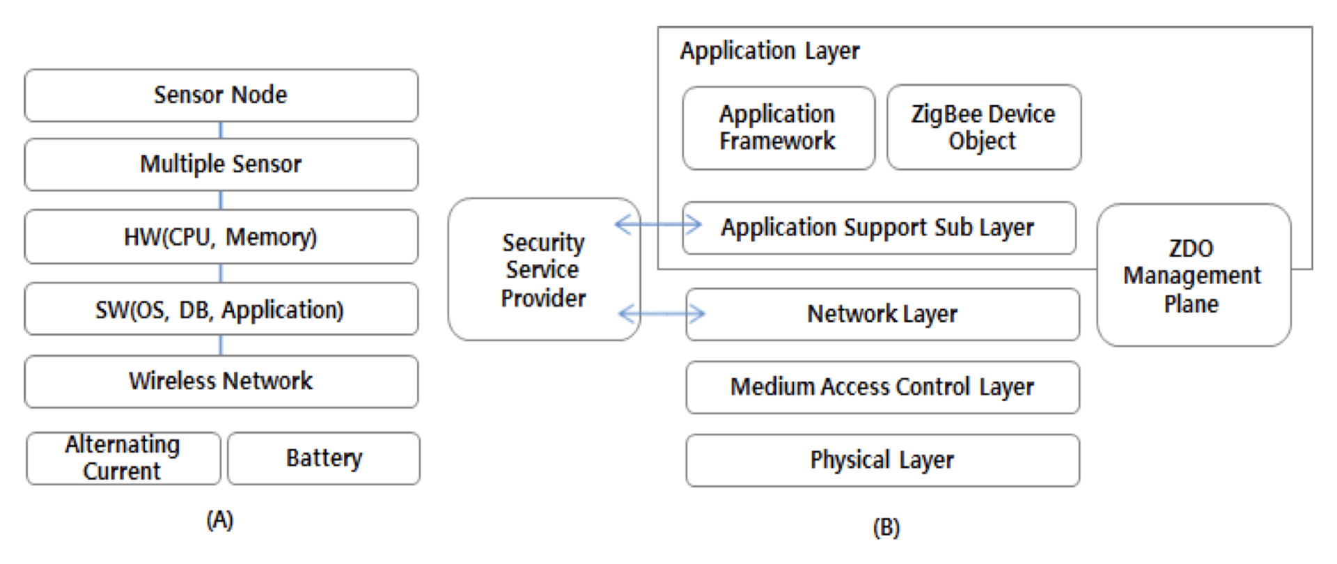

**Fig: Sensor Network (A) & ZigBee Protocol Stack (B)**

As shown in the above Figure (i;e Figure 1) the network of sensors consists of dispersed sensor nodes that measure both physical and environmental conditions such as pressure, temperature and vibrations which has the gateways that collect the information from the nodes wirelessly and transmit the information to the centralized servers and softwares to store and analyse the data. ZigBee is used for the wireless communication between the sensors during the emergency situations.

**System Design:**

Below flowchart describes about the flow of information which shows the intelligent optimal evacuation route with the guidance light based of various detectors depending on the type of disaster. According to the place of occurrence and type the emergency response system will design the path in difference conditions like fire, visibility and the number of evacuees. Guide light showing the direction for the evacuation are lit with the cooperation of disaster prevention system of the building and governments central disaster prevention system by exchanging the information bidirectional.

System composition modules are designed to comprise an Ember EM250 chipset, sensor modules, a CDD controller, a Communication module, a power modules, a CSD controller, an LED display and buzzers.

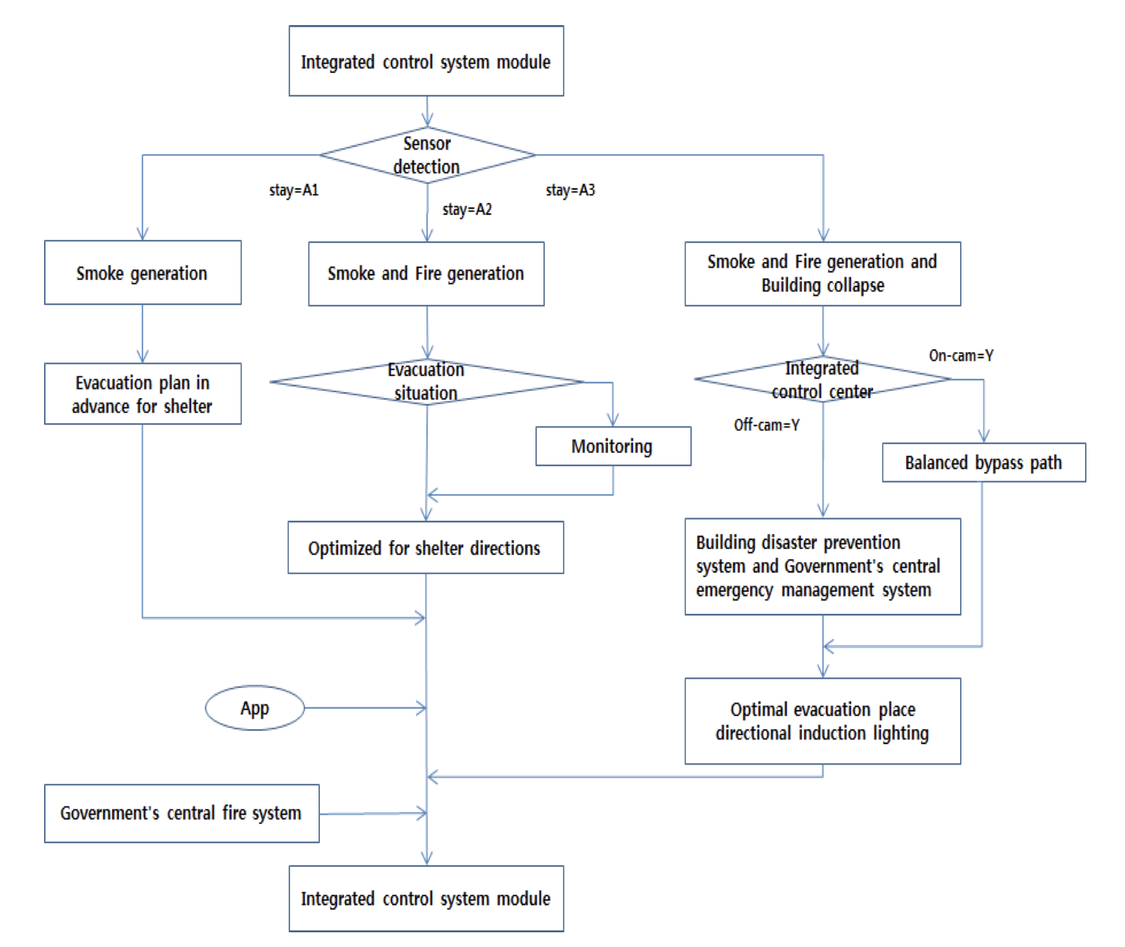

**Fig: Evacuation Simulation Flowchart**

The emergency lights are powered both with power and batteries and attaching some of the detectors like smoke, flame and heat. They are configured for bidirectional communication via wireless communication network.

**Dataflow:**

The emergency light creates and connection between the information which generates where information detected by various sensors placed in the emergency lights this information is analysed through the controlled and this kind of collected information is relayed to the centralized operating serves. Thus, when the disaster occurs the analysed path and messages are sent to smartphones as per the location of the evacuee.

The integrated system provides evacuees with their approximate location information and their detour for evacuation path with ignition based on first fire detection and location of fire. The integrated control centre and central disaster prevention system work together based prearranged evacuation plans.

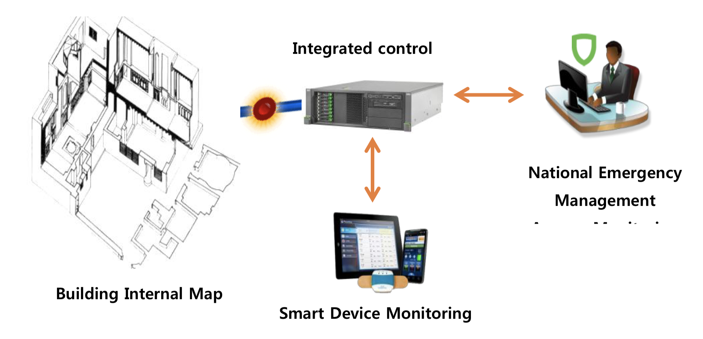

**Fig: Data Flow & system configuration**

**4) CONCLUSION**

**5) REFERENCES:**

[1] <http://internetofthingsagenda.techtarget.com/definition/Internet-of-Things-IoT>

[2] <https://www.safewise.com/home-security-faq/how-does-home-automation-work>

[3] <https://support.google.com/googlehome/answer/7073578?hl=en>

[4]<http://www.sersc.org>

[5]<https://www.lifewire.com/separate-components-theater-system-setup-1846358>

[6]<https://developer.amazon.com/alexa/connected-devices>

[7][https://developer.amazon.com/docs/ask-overviews/build-skills-with-the-alexa-skills-kit.ht ml](https://developer.amazon.com/docs/ask-overviews/build-skills-with-the-alexa-skills-kit.html)